13.68: The “spring constant” for this wire is 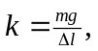 so

